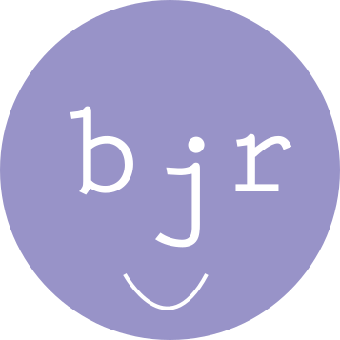

SPONSORSHIP PACKAGE 2017
Born Just Right invites you to join with other valued sponsors to support its first year of making an impact in the world.
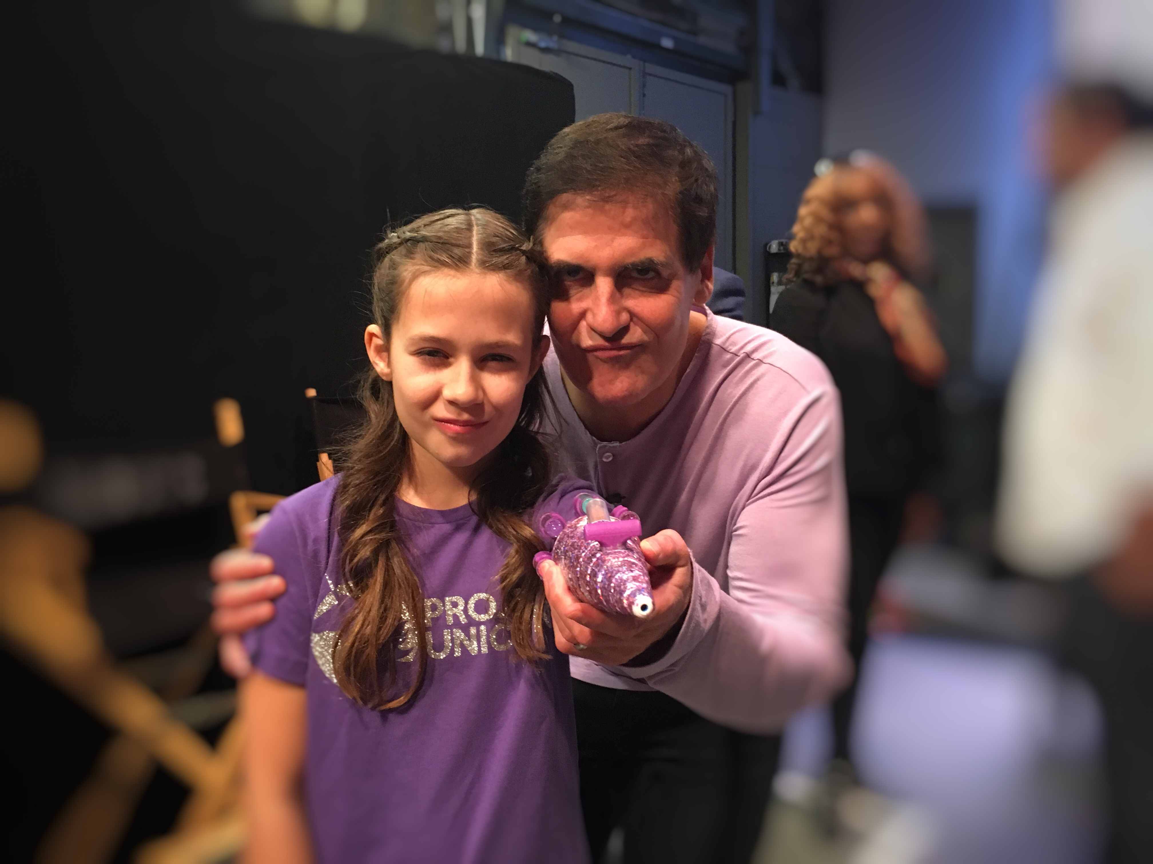
Contact:
Jen Reeves
jen@bornjustright.org
+1. 202.679.7082

What is Born Just Right?
We are a new non-profit with a mission to introduce design to kids who live with a disability. We know these kids have an opportunity to use design as a way to enhance their lives with fun or helpful solutions. We are building awareness about the power of design knowledge and creating opportunities for more design learning.

Why is this important?
- Growing up with an obvious difference does not have to be considered a negative experience.
- Encouraging and teaching kids to own and communication design needs can be life changing.
- Teaching kids design is just the beginning. It takes community and parents who know how to advocate for learning and design opportunities.
- Born Just Right is working to create opportunities for kids and parents or guardians to learn how to grow design visions into reality.
- Born Just Right is also working to raise more awareness on how important it is to change perception about disability. It is an opportunity to see design needs from a different and very helpful perspective.

Activities and Opportunities for 2017

July 16, 2017: Helping Hands East Design Day
In partnership with the Helping Hands Foundation and KIDmob, we are creating a day-long introduction to design to kids between the ages of 10-18 who have an upper limb difference or limb loss.
- Kids attending will get a hands-on opportunity to learn the basics of design and will leave with a fun or helpful concept they can work on beyond the one-day event.
- The end of this event will help kick off the creation of an online community of design kids and a separate community for parents and guardians who are design advocates.
- The goal of this event is to grow a one-day event into a full week-long design camp in 2018.

Public Speaking Opportunities
Jen and Jordan Reeves are lining up potential speaking opportunities through 2017. Travel may include events in Toronto, New York City and Washington, DC.
- Jordan continues to speak on the impact design brings to her life and how the creation of a glitter-shooting prosthetic arm opened her up to a whole new world.
- Jen speaks on how she uses advocacy to raise her kids into strong, confident kids. She also shares how advocacy helps support creativity and growth. (She also speaks about social media community building, management and digital literacy.)

Online Relaunch
Born Just Right was founded originally as an online community where a blog was its online format. We are relaunching into a full website to use as a place to tell our story but also raise awareness about our mission.

Sponsorship Opportunities
We invite you to join Born Just Right in supporting this important initiative. Sponsors receive positive brand association with a mission that has already sparked national attention. It also provides a distribution channel to share information and drive youth-driven engagement at the grassroots level with Cyber-Seniors 800+ partners that includes students, parents, teachers, senior citizens, caretakers, media, and community leaders.

BJR Design-Champion - $10,000+
- Premier recognition at all events – in person or online, including an opportunity to provide introductions or participate on panels.
- Premier logo recognition in all Born Just Right communications and website (home/sponsor page)
- Featured partner profile in Born Just Right’s and blog posts shared through social media and on the website
- Weekly shoutouts and sharing on Born Just Right social media channels
- Invitations to events and online conversations
- Invitation to present/share remarks for webinars, twitter chats and events
- Option to include quotes in national press releases, inclusion in media interviews, media kit
- And opportunity to collaborate with members of Born Just Right’s online communities
- First option to underwrite a Born Just Right event or contest, which allows naming rights and access/use of content of contest submissions and winner profile (testimonials, video interviews, photos) May require additional cost/in-kind contribution

BJR Design-Supporter - $5000
- Recognition at all events – in person or online, with opportunity to provide introduction or participate on panel at up to 5 events
- Logo recognition in all Born Just Right communications and website (home and sponsor page)
- Partner profile in Born Just Right newsletter
- Shoutout and sharing on Born Just Rights social media channels
- Invitations to events and opportunities to distribute material/giveaway at events
- Recognition in national press release and media kit

BJR Design-Friend - $2000
- Recognition at events, with the opportunity to provide introduction or participate on panel at 1 event
- Logo recognition in Born Just Right communications and website (sponsor page)
- Recognition in the Born Just Right newsletter
- Shoutout and sharing on Born Just Right’s social media channels
- Opportunity to distribute printed promotional material at events
- Recognition in national press release and media kit

BJR Design-Ally - $1000
- Recognition at screening events and tech labs
- Logo recognition in Born Just Right’s communications and website (sponsor page)
- Recognition in Born Just Right newsletter
- Shoutout on Born Just Right social media channels

In-Kind Sponsorships - We are looking for design/maker space, tech products for prizes or other fund giveaways, ad space,

